# Equivalence Partitioning in Python

Understanding the equivalence.py Script

The script performs equivalence partitioning based on the relation defined by lambda x, y: (x - y) % 4 == 0. Basically, this relation will partition the integers into classes such that the difference between any two numbers in the same class is divisible by 4.

Here’s a brief overview of what you might expect from the script:

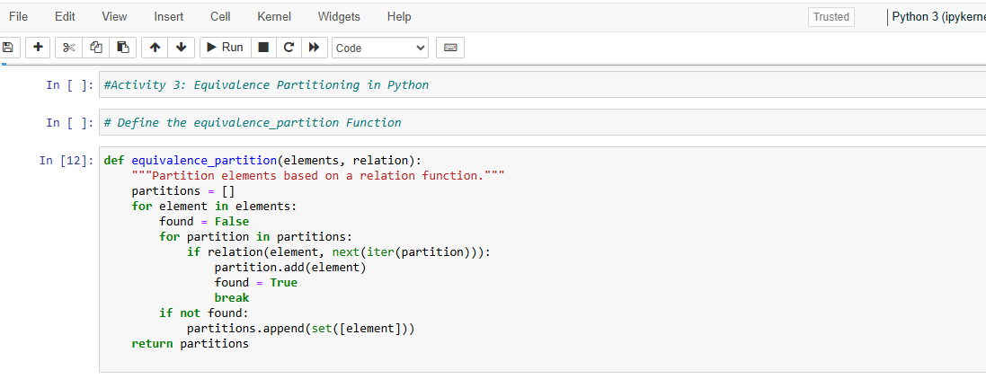

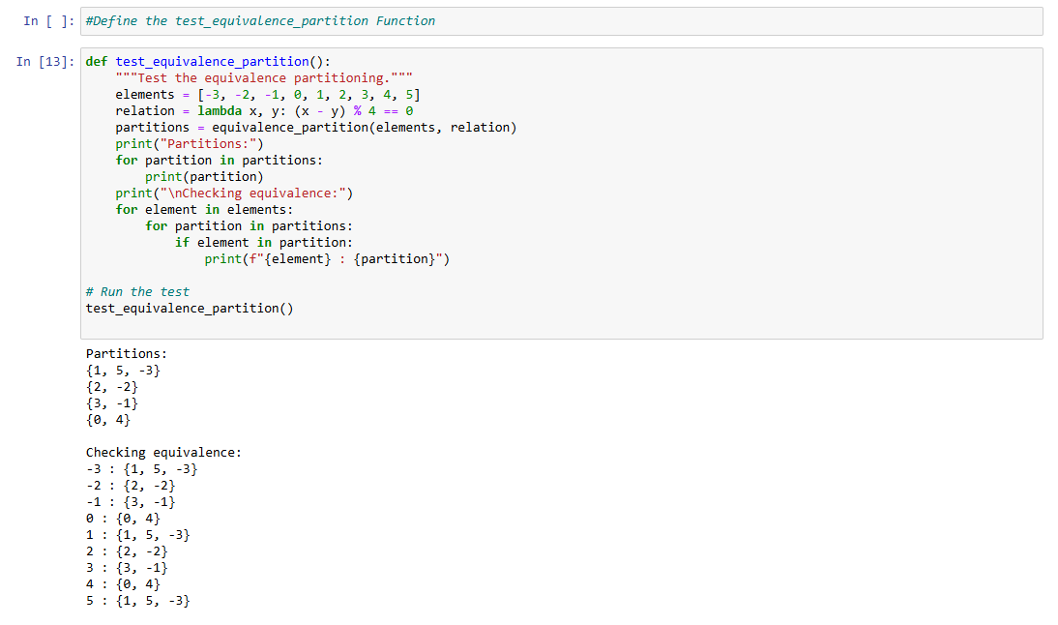

**Experimenting with the Code**

Play around with the addition of other elements to the list of elements to observe how they get partitioned. For instance, insert 6 or -4 and see how the partitions happen.

Modify the lambda function to use another modulus value or another relation. For example - instead of it use lambda x, y: (x - y) % 3 == 0 and see how partitions change.

Now implement the code for visualization of the partition, using a library like matplotlib, to understand how elements are being segmented.

**Example Experimentation**

